WORLD HISTORY (to 1300)  TERMS LIST | CUMULATIVE BENCHMARK  First Nine Weeks

HUMAN ORIGINS | MESOPOTAMIA | EGYPT
Vocabulary  Anno Domini  The “Humanities”  Special Creation  Evolutionary Theory  Theistic  Non-Theistic  Natural Rights  Social Darwinism  Lucy  Hominid  Technology  People  Cicero  Charles Darwin  Herodotus  John Locke  Malcolm X  Periods of the Stone Age  Paleolithic  Mesolithic  Neolithic  Art of the Stone Age  Venus Figurines  Cave Art | Vocabulary  Anthropomorphic  Benevolence  City-State  Cuneiform  Malevolence  Monotheism  Pictogram  Phonics  Polytheism  Propitiation  Rigor  Scribe  Stylus  Theocracy  Ziggurat  People, Literary Characters,  and Deities  Enkidu  Gilgamesh  Ishtar  Hammurabi  Marduk  Legal Terms  Rule of Law  Divine Right  Trial  Perjury  Burden of Proof  Liability  Discrimination | Vocabulary  Deification  Depose  Diffusion  Ethics  Ethical Religion  Hieroglyphics  Hyksos  Incarnation  Monotheism  Papyrus  Surveyor  Treaty  Deities  Amun-Ra  Osiris  Isis  Horus  Set  Ma’at  Pharaohs  Hatshepsut  Akhenaten  Nefertiti (wife)  Tutankhamun  Ramses II [the Great]

Students should be prepared to demonstrate basic knowledge of the following works read and discussed in class: | Students should also be prepared to discuss, compare, and contrast the religions of the ancient Mesopotamians and Egyptians, noting how geographic and social factors influenced the development of these religion.
The Story of Prometheus and Epimetheus
The Epic of Gilgamesh
Hammurabi’s Code
The Myth of Osiris and Isis
The Egyptian Book of the Dead

FIRST NINE WEEKS BENCHMARK TEST MAP

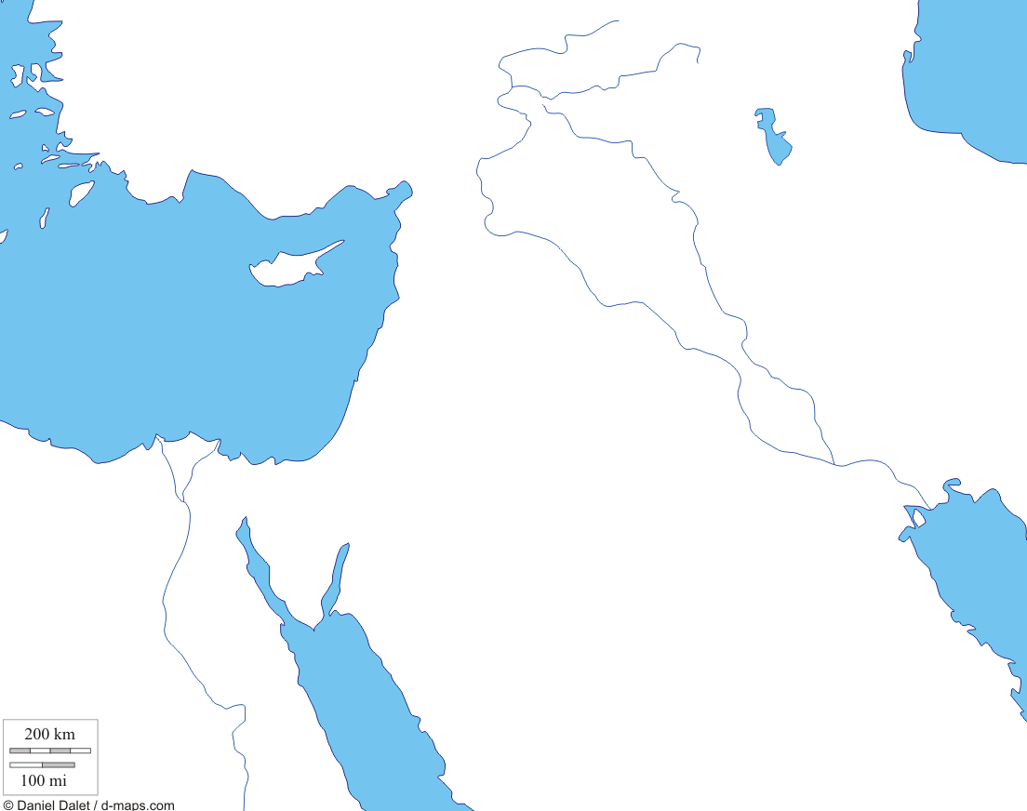

Bodies of Water | Regions | Cities | Continents
Euphrates River  Mediterranean Sea  Nile River  Persian Gulf  Red Sea  Tigris River | Fertile Crescent  Mesopotamia  Nile Delta  Lower Egypt  Sahara Desert  Sinai Peninsula  Syrian Desert  Sumer  Upper Egypt | Babylon  Memphis  Thebes  Ur  For more review materials, visit | Africa  Asia

